

SIMATS ENGINEERING

Saveetha Institute of Medical and Technical Sciences Chennai- 602105
Student Name: D.HEMASREE Reg. No: 192524114
Course Code: CSA0820 Slot: C
Course Name: PYTHON PROGRAMMING FOR SCIENTIFIC COMPUTING Course Faculty: DR.P.VIJAYARAGAVAN AND DR. ARUNA
Project Title: Python-Based Smart Medicine Reminder and Refill Alert System

Module Photographs:
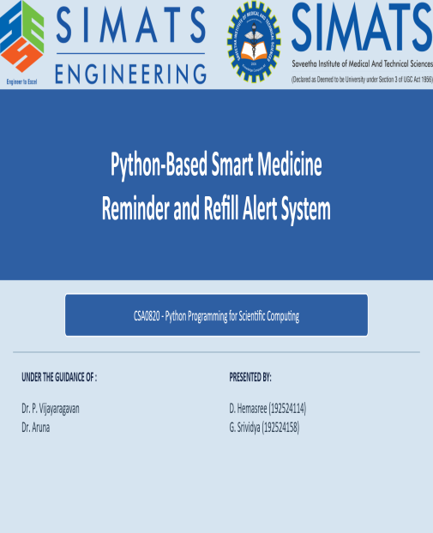 | 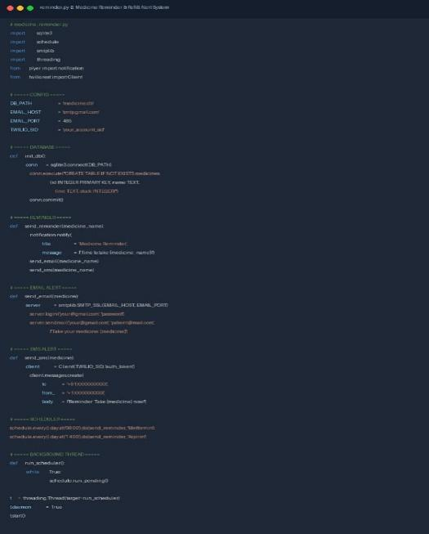 | 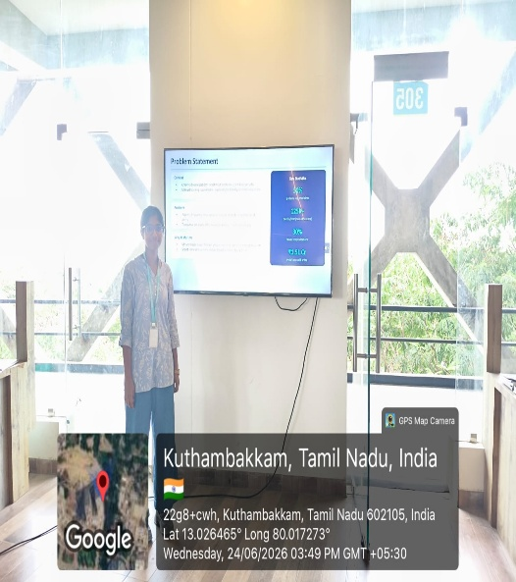
Project Description:
Medication non-adherence is one of the leading causes of preventable health complications worldwide, especially among elderly and chronic disease patients. Many patients forget to take their medicines on time or run out of stock without realizing it. To solve this real-world problem, we developed a Python-based Smart Medicine Reminder and Refill Alert System that automates the entire reminder and monitoring process without any manual effort.
The system uses an Arduino Uno connected to IR sensors that physically detect whether medicine is present in each compartment of the medicine box. Python communicates with Arduino through PySerial to receive this sensor data in real time. Based on the scheduled medicine timings stored in a SQLite database, the system automatically triggers alerts through desktop popups, email using smtplib, and SMS using the Twilio API whenever a dose is missed or medicine stock runs low.
The final outcome is a fully automated desktop application built using Tkinter that manages medicine schedules, tracks adherence history, and sends refill alerts before stock runs out. This system reduces dependency on manual reminders and lowers the risk of hospitalization due to missed doses. In the future, the system can be upgraded with Raspberry Pi for IoT connectivity, a mobile application, and machine learning for predicting patient adherence patterns.

Student Signature Guide Signature

